**Automotive Sales Trends and Market Dynamics Analysis**

1. Title of the Analysis

Automotive Sales Trends and Market Dynamics Analysis

1. Introduction

Purpose of the analysis:

This analysis aims to examine the intricate patterns of automotive sales, evaluating how various factors such as model diversity, color preference, geographic distribution, and transmission types influence market performance for key industry players. The aim is to identify successful strategies, potential areas for growth, and consumer trends that can inform future business decisions, optimize inventory and production, and enhance marketing efforts to align with consumer demand.

Describing the dataset:

The "Vehicle Sales and Market Trends Dataset" offers extensive data related to the transactional details and sales activities of a diverse range of vehicles. It is collected from Kaggle using the link : <https://www.kaggle.com/datasets/syedanwarafridi/vehicle-sales-data>. This dataset encompasses details such as the year, make, model, trim, body type, transmission type, VIN (Vehicle Identification Number), state of registration, condition rating, odometer reading, exterior and interior colors, seller information, Manheim Market Report (MMR) values, selling prices, and sale dates. It has a total of 558,837 records which is a good amount of data for the analysis. This dataset consists of good number of measures and dimensions which helps in visualizations.

3. Analysis Methodology Followed

Which analytical tool was considered (Power BI or Tableau) and any other info about them*.*

Tableau has been the chosen analytical tool for the analysis that has been given. Tableau, which is renowned for its powerful data visualization features, is used by a wide range of professionals worldwide, such business leaders and data analysts. It differentiates itself an industry leader in the field of contemporary business intelligence by expediting the production of insightful findings and streamlining the data exploration procedure. Tableau's user-centric product design is a reflection of its core aim of enabling people to see and comprehend data. This user-friendly platform facilitates a smooth transition from data connection to collaboration, making it an all-inclusive and adaptable choice for decision-making based on data in a variety of industries.

Explain the visualization creation process *(minimum 4 to 5 sentences)*and using a couple visualization screen shots.

Visual1:Total Selling Price Breakdown by Make and Qaurter

Process:

1. Drag the make column to the column shelf.
2. Drag the Mmr column to the rows self.
3. On the top tool, click on sorted descending.
4. Drag the salesdate column to the color tab in Marks.
5. By default year is selected for salesdate convert that into quarters, click on the dropdown present in the on salesdate and select the quater.

Visual2: Comparative State-by-State Sales Map: Ford vs. Chevrolet.

Process:

1. Drag the state column to the canvas.
2. Drag the salesprice measure to the size in the Marks tab.
3. Drag the Make column to the filter.
4. Select the Ford and Chevrolet.
5. Drag the Make column to the Color in the Marks tab.

Visual3: Aggregated MMR Values by Vehicle Make and Interior Color

Process:

1. Drag Make column to column shelf.
2. Drag MMR to the Rows shelf.
3. From the Top toolbar, click on sorted descending.
4. Drag Interior column to the color tab in the Marks.

Final Dashboards:

Dashboard1: Automotive Sales Overview

Dashboard2: Automotive Market Insights: Pricing, Popularity, and Preferences

Dashboard3: Ford vs. Chevrolet: A Comparative Analysis of Sales Trends

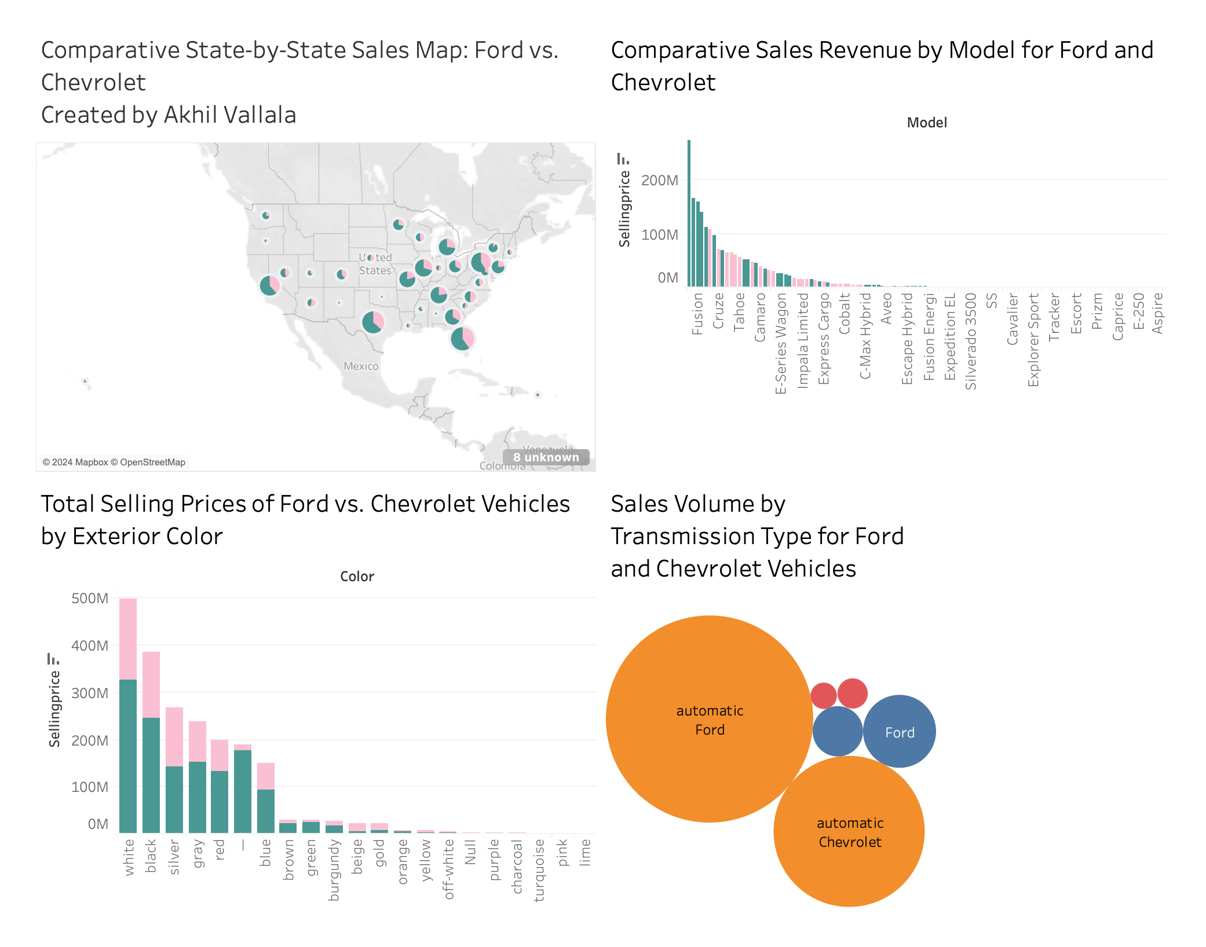

1. Analysis Results

Insights from Dashboard1:

|  |  |  |  |
| --- | --- | --- | --- |
| S.no | Positive | Negative | Comments |
| 1. | A line graph showing the strength of sales prices over time shows a significant peak at the end of 2014. This indicates a potentially successful vehicle sales period that can be affected by end-of-year sales, new model launches or seasonal buying patterns. Such trends are valuable in planning inventory and marketing strategies for these peak periods to maximize sales. | A spike in sales prices in the last quarter of 2014, followed by a sharp decline, may indicate market volatility or a one-time sales event. If this peak is not part of a continuing trend, it may not be reliable for predicting the future. | Together, the visualizations illustrate different consumer preferences for vehicle condition, brand choice, and geographic distribution. It emphasizes a customized approach to inventory, marketing and sales strategies to effectively respond to the diverse needs of consumers.. |
| 2. | The car condition table shows a healthy concentration of vehicles in moderately good condition. This shows that the majority of cars sold have been well maintained, which is likely to attract buyers looking for reliable used cars. A consistent supply of vehicles in good condition can improve a dealership's reputation for quality. |  |  |
| 3. | The map visualization shows that some states have higher sales volumes, which may indicate areas with strong market demand or effective sales strategies. These areas could provide opportunities for further market development and targeted advertising campaigns to capitalize on the existing customer base and attract new buyers. |  |  |
| 4. | A bar chart showing the top ten best-selling brands shows strong brand preference, led by Ford and Chevrolet. This points to the loyal customer base and strong presence of these brands, underscoring the importance of stocking popular brands to meet consumer demand. |  |  |

Dashboard2: Automotive Market Insights: Pricing, Popularity, and Preferences

Insights from Dashboard2:

|  |  |  |  |
| --- | --- | --- | --- |
| S.no | Positive | Negative | Comments |
| 1 | The "Total Sales Price Breakdown by Brand and Quarter" bar chart shows notable sales numbers for specific brands during specific quarters. These sales figures can be correlated with strategic releases of new models or seasonal campaigns, highlighting the effectiveness of targeted marketing efforts during these periods. | The "Market Value Breakdown by Shipment Type" bubble chart shows the difference in market values ​​based on shipment types. This suggests a possible mismatch with market demand, risking overstocking of less popular shipments and highlighting the need for inventory that reflects trends in consumer preferences. | The lower part of the bar chart of the total sales price distribution by brand and quarter shows the number of zero entries, which may indicate incomplete data collection or input errors. Addressing these gaps is critical to providing comprehensive and accurate market analysis that informs future strategies. |
| 2 | The "Vehicle Model Diversity by Manufacturer" bar chart shows model diversity by manufacturer. This variety can meet many needs and preferences of consumers, allowing a wider market appeal and proving the adaptability of the producer in a competitive industry. |  |  |
| 3 | The "MMR Aggregate Values ​​by Vehicle Make and Interior Color" bar chart shows that vehicles with certain interior colors tend to retain higher market values. This information can be key to creating sales strategies that emphasize stockings and promote models with recommended interior colors to maximize revenue. |  |  |
| 4 | The packaged "Sales Breakdown by Vehicle Make and Exterior Color" bubble chart highlights consumer color preferences when purchasing vehicles. Understanding these trends can lead manufacturers and retailers to adjust production and inventory to meet consumer preferences, which can increase sales and customer satisfaction. |  |  |

Dashboard3: Ford vs. Chevrolet: A Comparative Analysis of Sales Trends

Insights from Dashboard 3:

|  |  |  |  |
| --- | --- | --- | --- |
| S.no | Positive | Negative | Comments |
| 1 | The "Comparative State-by-State Sales Map" shows varying sales volumes across different states for Ford and Chevrolet. This suggests strong regional market presence for these brands, with certain states demonstrating higher sales potential. Such geographic patterns could be leveraged to optimize distribution and focus marketing efforts where the brands are performing well. | While the state sales map shows areas with strong sales, it also highlights areas with lower sales volume, which may indicate underperformance or market neglect. It is important to understand why sales are lower in these regions in order to solve potential problems and ensure a balanced sales strategy in all regions. | The dashboard brings together different aspects of sales information and offers a multidimensional picture of the car market. This holistic approach is essential for a comprehensive understanding of performance, enabling data-driven decisions in production, marketing and sales planning.. |
| 2 | The "Ford vs. Chevrolet Model Comparisons" bar chart shows that certain models, such as the Ford Fusion, bring in sales. This can inform product priorities and marketing efforts, focusing on models with proven market success to drive future sales. |  |  |
| 3 | The "Ford vs. Chevrolet Vehicles by Exterior Vehicles" bar chart shows that certain colors, such as white and black, are more popular and can lead to higher sales prices. These trends provide manufacturers with valuable information when deciding on color options for new models. |  |  |
| 4 | The "Ford and Chevrolet Vehicle Sales Volumes by Transmission Type" bubble chart shows that automatic transmissions are significantly preferred over manual transmissions. Being aware of this trend allows manufacturers to better adapt their products to consumer preferences, which can increase sales efficiency. |  |  |

1. Conclusion:

Analysis of car sales panels concludes that market success is multidimensional and strongly influenced by factors such as vehicle model popularity, exterior color preferences, regional market forces, and transmission types. Ford and Chevrolet show a strong brand presence with certain models and colors driving significant sales, while automatic transmissions dominate consumer preference. Geographic analysis indicates that key states are high-selling regions that offer potential for targeted marketing and expansion.

However, quarterly sales volatility and underperformance in some regions suggest a strategic review. In addition, the preference for certain interior color combinations suggests possible marketing strategies. Insights from this analysis underscore the need for automotive operators to be skilled and experienced in sales strategy, inventory and production planning. Going forward, a balanced and consumer-centric approach that takes these findings into account will be critical to maintaining and increasing market share in a competitive environment.